OO Design
Name: Chuyang Lin
PawPrint: 14224148
Checkers Game Data Model Concept
Description: create a data model concept for the game of Checkers (Draughts).
Required Classes:
Class Player
Name // Display player name
Color // LIGHT OR DARK
Status // HUMAN OR BOT

Class CheckerStats
Stats // determine what type of checker it is
Color
Class GameBoard
Array // 2d array from 0-7
Winner // NULL, Dark, light or draw
Condition // Playing or End

Required methods:
getPlayers:
• Collect and display the player names.
• Display a board with pieces the user can interact with if one or both players are human.

assignTurns:
• Determine who moves first and gets assigned the black (dark) pieces.
players get assigned their respective color as black (or the darker color) traditionally for the one who goes first and red (or the lighter color) for the player who goes second.

Generater:
A Checkerboard object can be made that has two arrays from 0-7 or that have 8 spots each. These will be the coordinates of the spots on the checkerboard that are determined by the numbers in the 2-Dimensional array.

MovesChecker:
• Prevent illegal moves.
• determine what moves are possible/allowable.
• determine if a move is illegal.
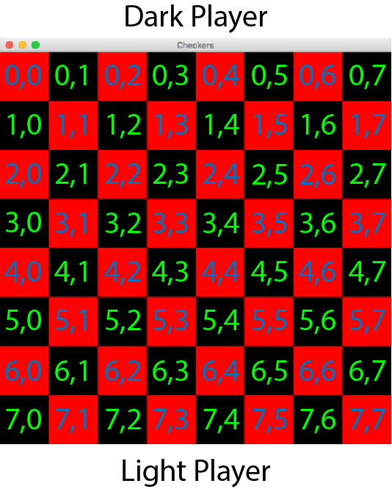
Logic such as: Different types of checkers have different legal moves. Checkers can only move diagonally and on black spaces. A checker cannot move into a space that is red or occupied by another piece which can be checked by a status attribute on a square or a squareColor attribute. A checker can hop over an enemy colored piece in that is in the directions as mentioned above and if there is a square of the correct color on the other side.

ConditionsChecker:
• Identify when there is a winner, loser, or if a draw has occurred.
• determine whether the game status is playing or end
One player will win if they have captured all other pieces from the opposing player. Both players can have the match result in a draw if neither player has any legal moves left. A winner name or a text “draw” will be displayed and the game status will turn to end as long as Winner attribute is not null

